Evidence for the PDA in software development

A & D - Analysis and Design Unit

Benjamin Bowen

Cohort E17

A.D. 1

A Use Case Diagram



A.D. 2

A Class Diagram



A.D. 3

An Object Diagram

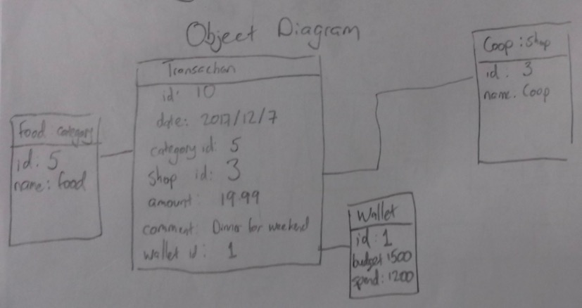

A.D. 4

An Activity Diagram

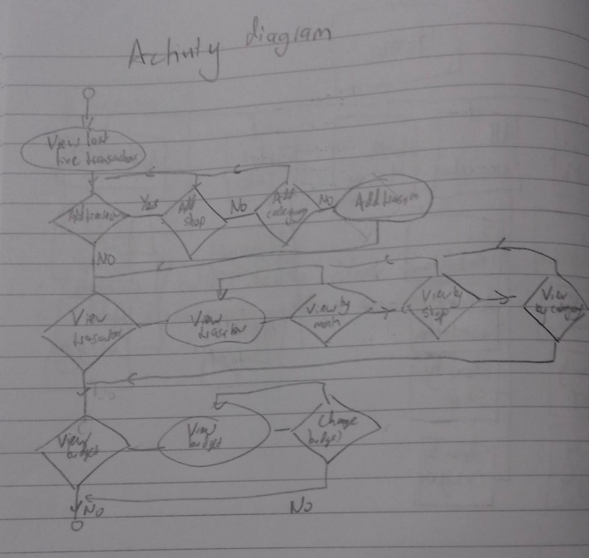

A.D. 5

An Inheritance Diagram



A.D. 5

Produce an Implementations Constraints plan detailing the following factors:

* Hardware and software platforms
* Performance requirements
* Persistent storage and transactions
* Usability
* Budgets
* Time

|  |  |  |
| --- | --- | --- |
| **Topic** | **Constraint** | **Solution** |
| Hardware and software | The app does not show properly on a mobile phone screen, which would limit the use of the product as users cannot use unless they have access to a computer. This would limit the number of users who buy the app to use on the go. | Use media queries in css to change layout if width/height is less than a set value. |
| Performance requirements | Has to run in all commonly used browsers, if someone is using an older version of a browser certain features may not render correctly and therefore stop using the app. | Check e.g. with <https://caniuse.com/> if unsure about recent css/html. |
| Persistent storage and transactions | Data needs to persist when app is closed as the user will want to input data/use the app and then close it. If data does not persist the app would be obsolete and nobody would use it. | Using PostgreSQL to store data in a database. |
| Usability | User needs to be able to quickly recognize and log a transaction, as if they cannot find the correct way to input data then they will stop using the app. | Different colour of ‘Add a transaction’ button. Large font and clear spacing on input data page. |
| Budget | Cannot buy new software and must use a free hosting site. This means that photoshop cannot be used for app logo and there are limits on the amount of data that can be saved. | Use software already installed on computer. Must stick to size limit of hosting site. |
| Time | Project to be completed in a week. If the app is not functional at this point, feedback cannot be given and corrections and improvements can not be made. | Limit the amount of functionality. Have a clear well defined MVP and break down tasks into sprints. |